**DAILY ONLINE ACTIVITIES SUMMARY**

|  |  |  |  |  |  |  |  |  |
| --- | --- | --- | --- | --- | --- | --- | --- | --- |
| **Date:** | **01-06-2020** | | | | | **Name:** | **Anix Jugal D’Cunha** | |
| **Sem & Sec** | **8 sem , A sec** | | | | | **USN:** | **4al16cs013** | |
| **Online Test Summary** | | | | | | | | |
| **Subject** | | **SMS** | | | | | | |
| **Max. Marks** | | **60** | | **Score** | | | **60** | |
| **Certification Course Summary** | | | | | | | | |
| **Course** | **Complete Python Bootcamp : Go Beginner to Expert in Python 3** | | | | | | | |
| **Certificate Provider** | | | **Udemy** | | **Duration** | | | **10.5 hours** |
| **Coding Challenges** | | | | | | | | |
| **Problem Statement:** Find the leaders in the array | | | | | | | | |
| **Status: Completed** | | | | | | | | |
| **Uploaded the report in Github** | | | | | **yes** | | | |
| **If yes Repository name** | | | | | **alvas-education-foundation/dcunhaanixjugal** | | | |
| **Uploaded the report in slack** | | | | | **yes** | | | |

Online Test Details: (Attach the snapshot and briefly write the report for the same)

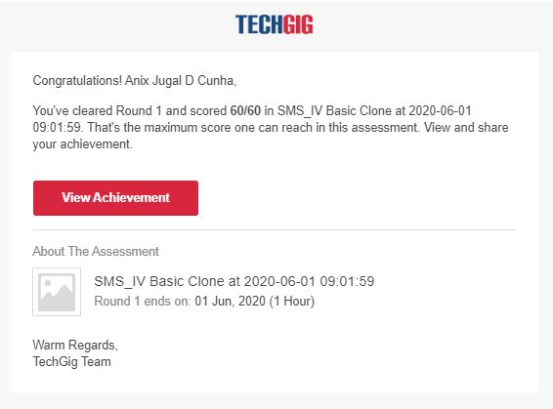

Certification Course Details: (Attach the snapshot and briefly write the report for the same)

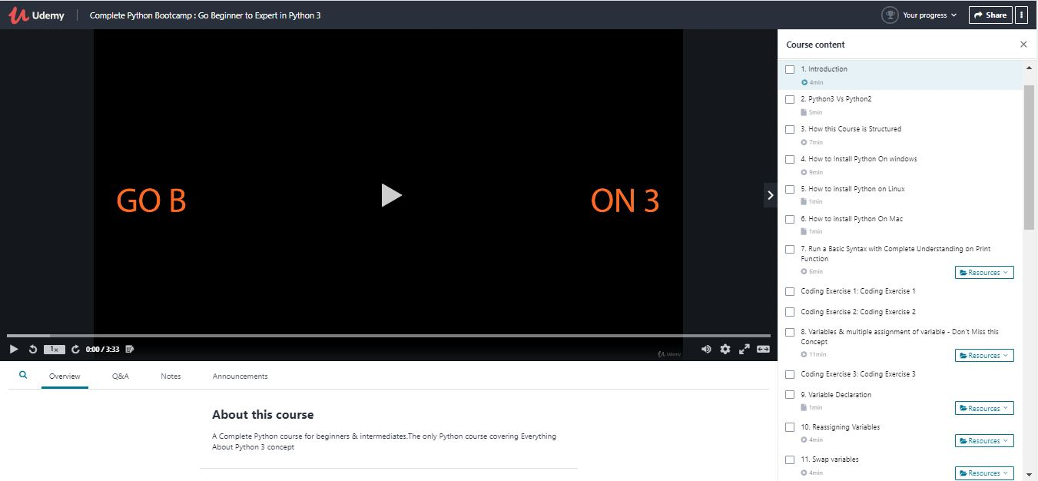

Coding Challenges Details: (Attach the snapshot and briefly write the report for the same)

Program 🡪Find the leaders in the array

#include<stdio.h>

void main()

{

int n, i, j, a[10];

printf("Enter the value of n: ");

scanf("%d",&n);

printf("Enter the numbers:\n");

for(i=0;i<n;i++)

scanf("%d",&a[i]);

printf("The leaders are\n");

for (int i = 0; i < n; i++)

{

j = 0;

for (j = i+1; j < n; j++)

{

if (a[i] <= a[j])

break;

}

if (j == n)

printf("%d ",a[i]);

}

}